Energy Generation by Source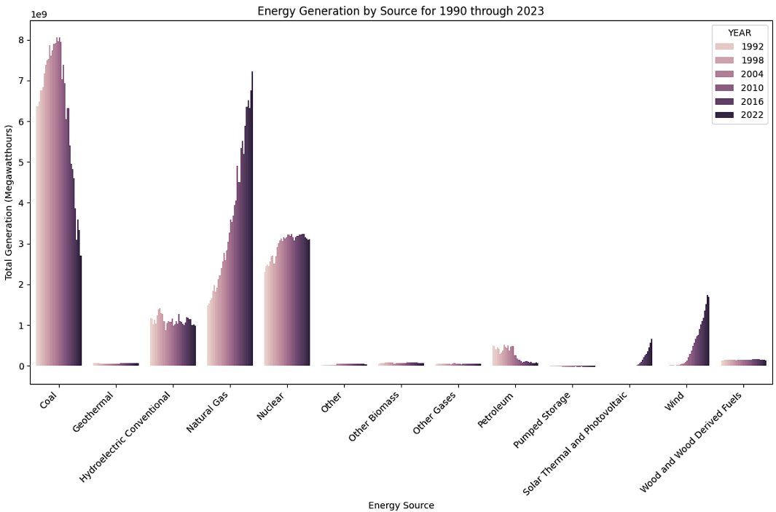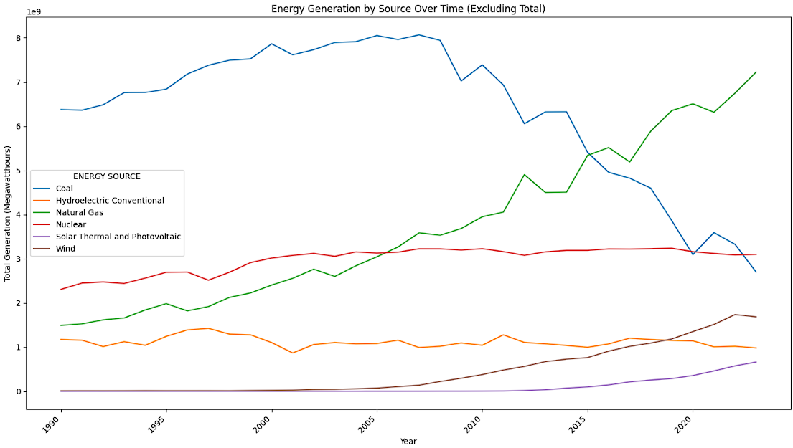

The above chart shows the change in energy generation by different sources over the course of 33 years. Some key takeaways are:

* Coal powered energy generation has drastically decreased, starting roughly around the year 2000
* Natural Gas powered energy generation has continuously increased throughout the observation of the data
* Solar Thermal and Photovoltaic powered energy generation began increasing slowly, starting roughly in 2010
* Wind powered energy generation began steadily increasing starting roughly around the year 2000
* Nuclear powered energy generation has remained relatively constant throughout the observation of this data

Energy Generation by Median Income Quartile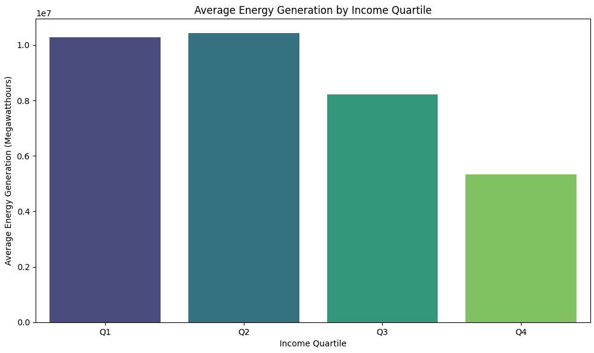

The above chart shows the breakdown of energy generation by median income quartiles, using state level data. One key takeaway is that it appears that the lower quartiles for median income generate more energy than those in the higher median income quartiles.

Median Income and Total Energy Generation

